How to download, fill in and attach Reading/Maths test results form for initiative evaluation
1. Go to co-ordinators page
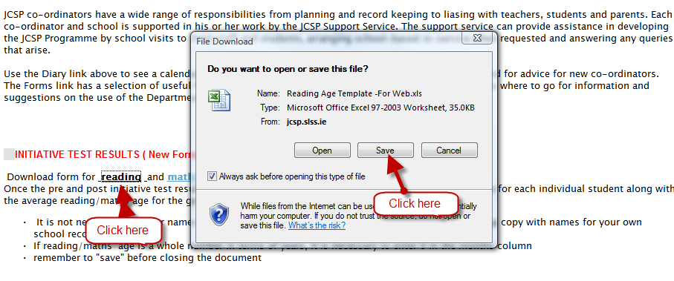2.
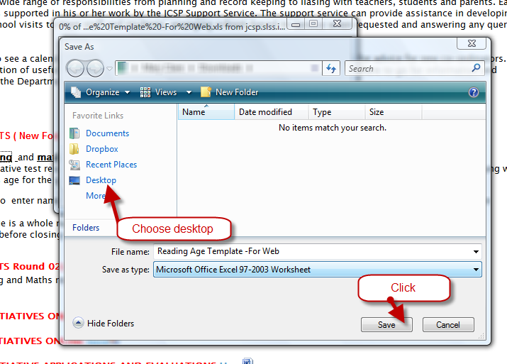
3. 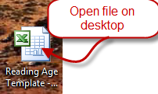
4.
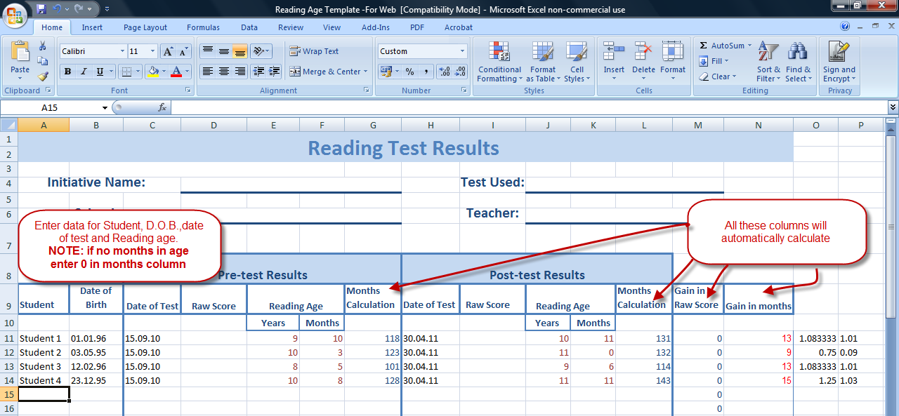
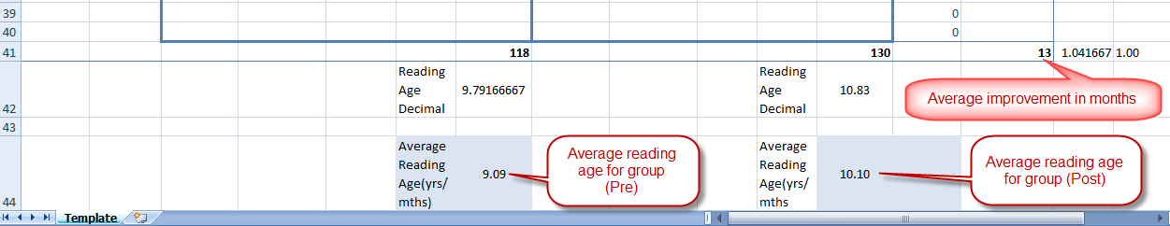

5. Save
6. Upload saved file
